OS

Q.why Os ?

ans -> os act as interFace for the resource management ( CPU ,memory ,GPU ,disk )

ii) protect app for bulkyness .

iii) no isolation and memory protection



Goals while devloping os :

i) maximum cpu utilization

ii) no process starvation

iii) high priority excution

Type of os :

1. single processing os

ii) batch processing os

iii) multipProgramming os (contest switching and pcb (process control block , ready queue ))

iv) multi tasking os ( similar to multi programing , contest switching , time sharing ,quntam time )

v) multiProcessing os (contest switching , time sharing , cpu>=1) eg : windows

vi) distributed os (many no of cpu connected through network )

vii) real time os (use with powerful os whhere chances of error is less ) eg : flight control system



Lec 3 :

what is process ?

ans – programm under excution . PROCESS EXCUTE IN RAM

what is thread ?

ans – thread is independent sub-task that is happening under process .

eg : in a application hum use se kuch information le rahe hai and hum chahe hai ki data cloud par store kare uske hum thread kahege .

eg : when we write in text editor , it do the speeling check , word suggestion and many more opreation throught therad .

what is multi threading ?

ans- multi threading is fast excution of process through thread which will perform indepedently with main process .

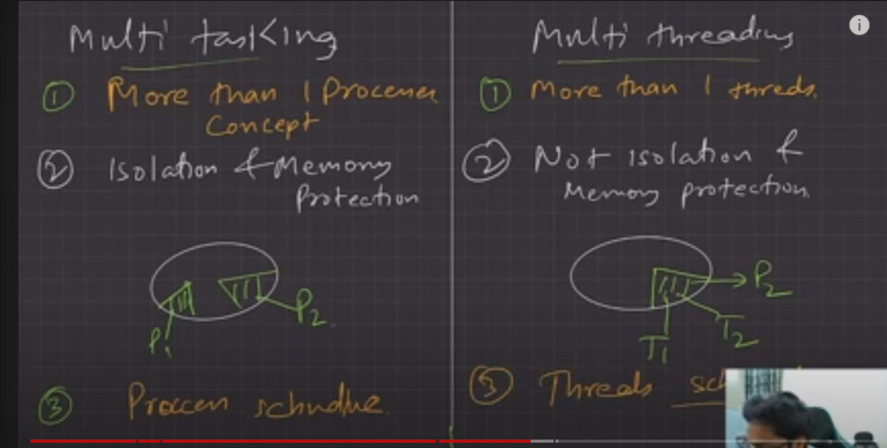

note : no of CPU in multi-threading is more than 1. (other wise we keep on doing contest switching and we will not be able to get the gain of threading ) .

Thread Sheduling : In Thread shduling threads are shedule on the bais of high priority excution .

diffrence between contest switching of process and thread :

i ) Basic diffrence

ii) In contest Switching of thread there will bo no switch of memory address because it is hapening in the same process .

iii) contenst swithcing of thread is fast .(because it is hapening in the same process and the will more than 1 cpu involved in multi-threading operation .

iv) cpu chache state is preserved in contest switching of thread but it will flused in case of proesses contest swithcing .

(note : chache : is kind of memory that is faster than cpu )

lecc 4 –

Component of os -:

i)user Space (app run in user space , it has no acess of hardware,it provide a convienent enviorement to user app, it intract with the kurnel )

ii)karnel (karnel have the acess of underline hardardware, function of kurnel is of process management (process creation,termination,thread sheduling,),kurnel handle the contest switching , time sharing

ii) function of kurnel is meomry management :memory allocation / memory deallocation/free space management )

iii ) file management : file crate/delete , directary management

iv) I/O mangement : pendrive plugin / airphone plugin

The other main function of kurnel is :

i) sponning

ii)burffring

iii)caching

Types of kurnel :

i )monolethic kurnel : ( all the above management process ,memory,file, i/o management is control by same kurnel )

advantages : fast commnication between user space and krunel (because every is in kurnel )

disadvantages : krunel beacome more bulky , less reliable (beause koie bhi ek compoenent corrept huwa to sare compoent corrept hojye ge )

ex : linx

)

ii)micro kurnel :in micro kurnel we put only major compoent in kurnel other wise we put them in usespace

eg : we put process management ,and memory managemnt in kurnel and put file and i/0 management in user space .

iii) hybirde kernel :

we will going to put file compoent in user space and remaning all compoent in kurnel

eg : mac os ,windos 7+

os artitect :

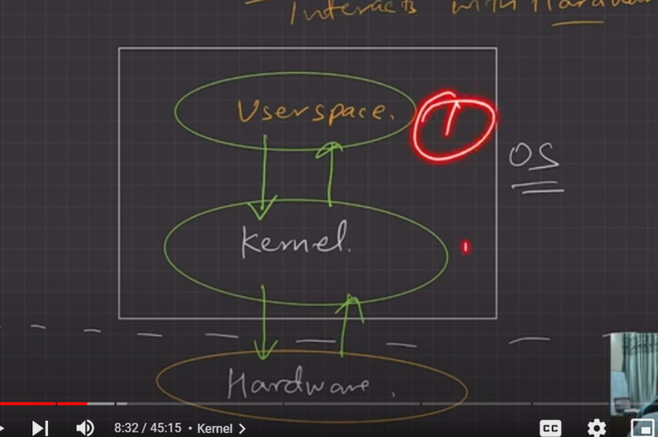

eg : for running a programm of hellow – first we will going to write command in terminal (which is acts as usespace) and then the terminal intract with the kurnel and our programm excute

Q. how user two process commnicate ?

they commnicate through IPC (inter process commnication )

in IPC – they commnicated through i) shared memory ii)message passing

LEC-4

System calls interface :

system calls is a mechanism through which we can swith from user space to kurnal sapce to get the acess of hardware .

eg . if we want to create a folder we go to terminal and enter mkdir the through systerm call interface the the request is passed to kurnel and kurnel create a node and connected that node with the root and our folder created.

user space ->kurnal space ?

i ) when we excute a task .

ii ) there will be software intrupt ( means high priority excution of system call to do the switching from use space to kuranl space )

Types of system call : 5 types

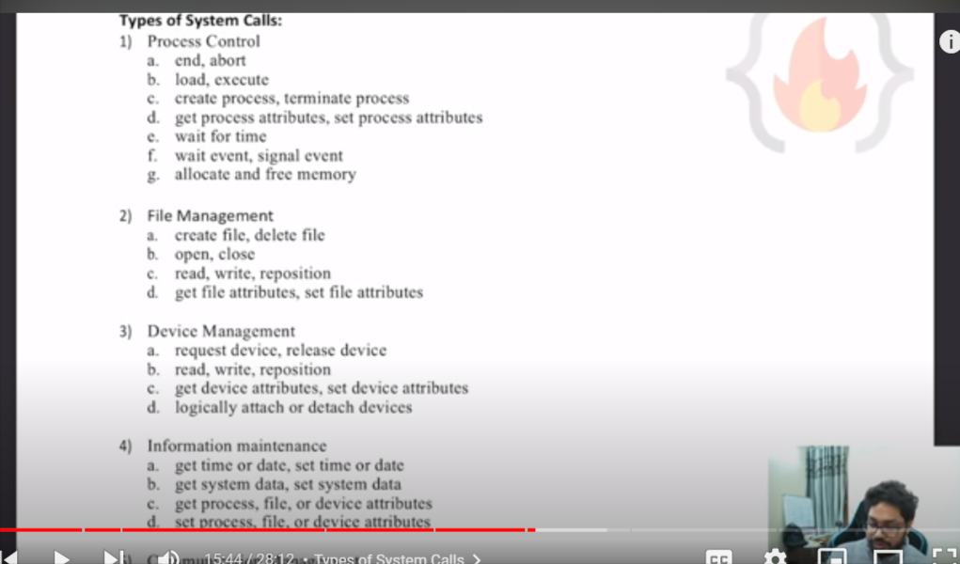

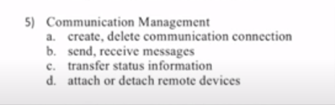

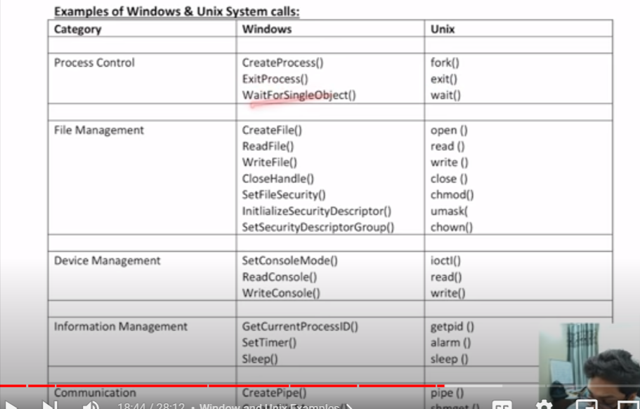

LEC-5

How operating system boots up ?

We can understand it in simple 5 steps ?

1. Power on

power on ->power suply to hardware, gpu and all, mother board

2. CPU loads BIOS or UEFI ( BIOS is cheap in a program is sotred about how to insitalize the ,UEFI is upgraded version of BIOS )

3. BIOS or UEFI runs tests and initalize hardware

4. BIOS or UEFI hands off to bootdevices ( disk (SSD OR HDD ), bootloadeer (contains programm about loading the os which locates at the 0 index of memory )

5. Bootloader loading the os

LEC-6

Diffrence between 32-bits and 64-bits os ?

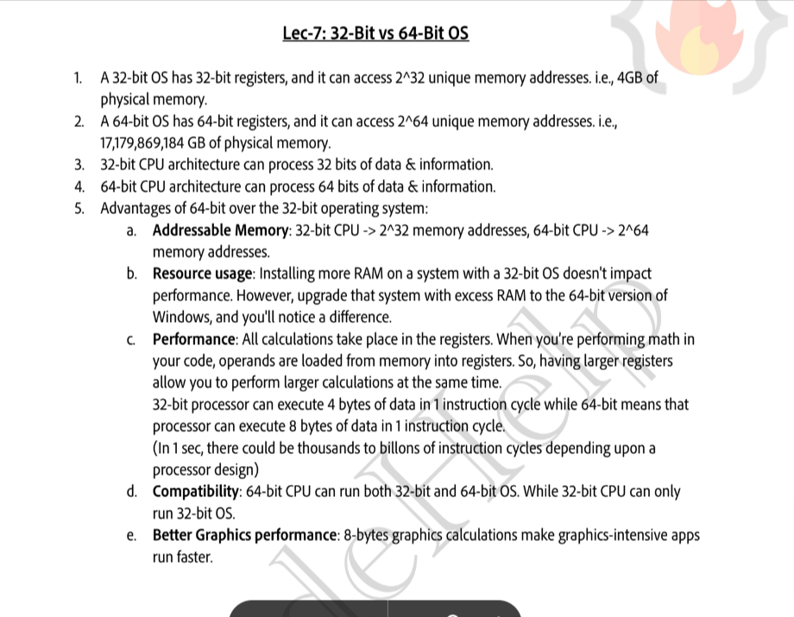

LEC-7

diffrent stroge used in computer :

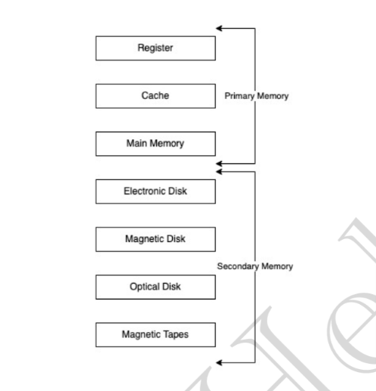

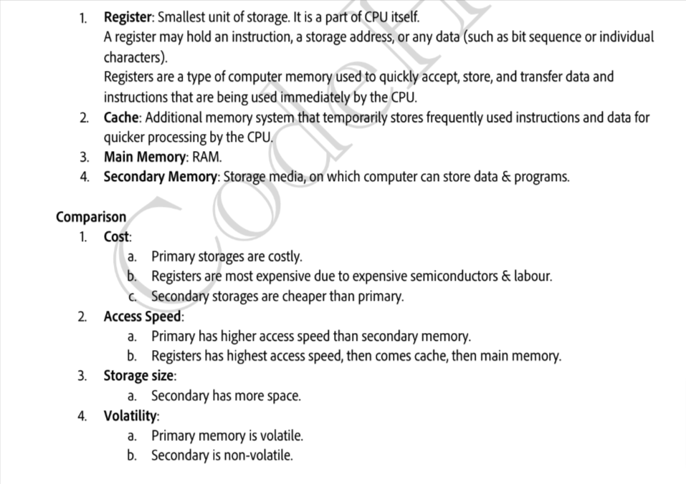

LEC-8

How Os create Process:

we can understand it in 5 steps :

1. os load the programm and static data (used for inistialization of programm ) to main memory (ram )

eg : i have crated a programm with .cpp extension and in that programm i have define a variable as string name=”ajaj” name will be my static data

2. os allocate run time stack (stack is part of memory used for local variable , fn argument and return value )

3. os allocate heap ( part of memory used for dynamic allocation )

4. i/o tasks

5. os handoff to main and process has been created and it is in under excution

eg : we create a .cpp file -> we run it ->compiler compile it and create a .exe file -> then it will going to do it input output

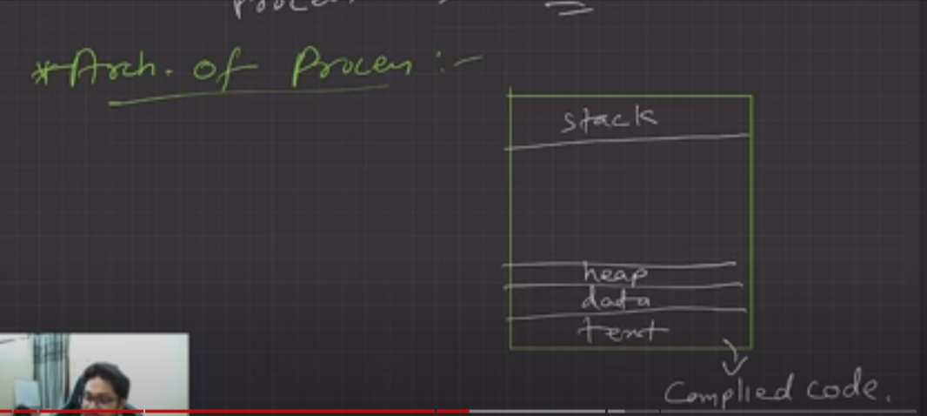

attributes of process :

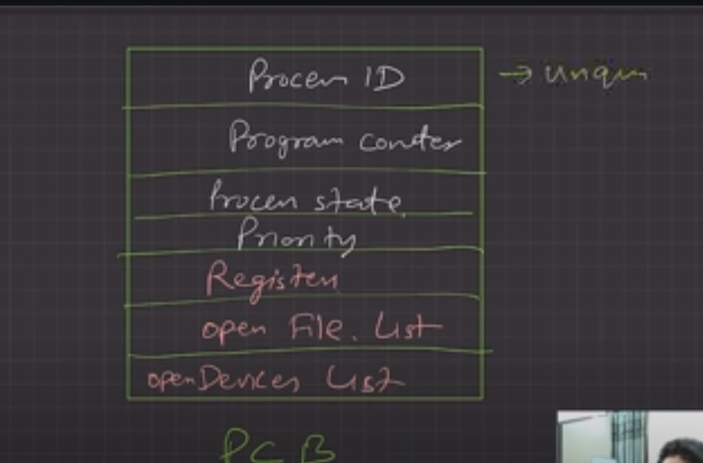

programm counter : in excuteable file each excutable line of code convert into instruction , with the help of programm couter these instruction excuted .

PROCESS STATE:

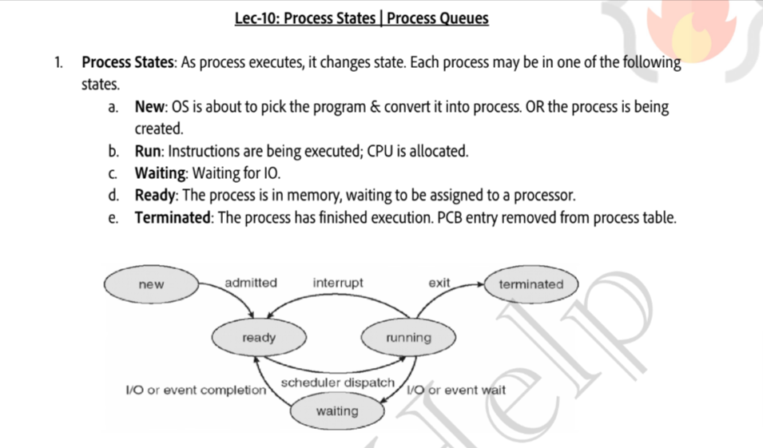

process queues:

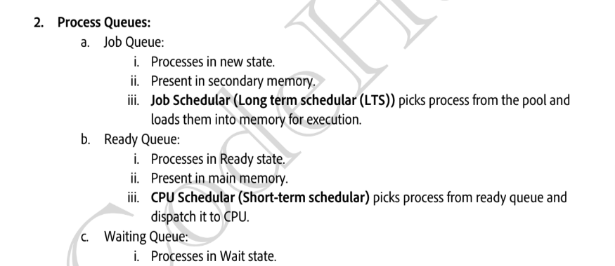

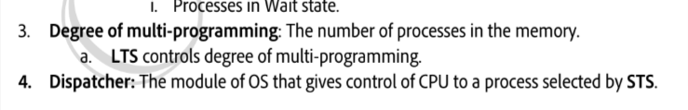

LTS:Long term shedular (job shedular is LTS)

STS :(Short term shedular : CPU shedular is STS)

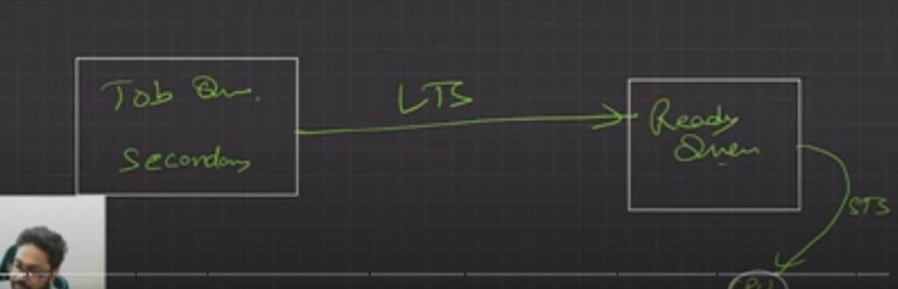

LEC-9

SWAPING :

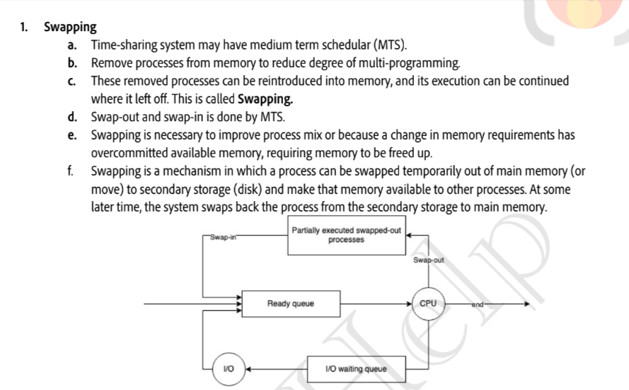

2.CONTEST SWITCHING

3. ORPHAN PROCESS

suppose we have one process ,from that process we created more subporcess , then what happend is the parent process get terminated , so os what it will going to do is it will going to assign the parent of orphan process to init (becase init it parent of all the process in os )

4.Zombi process

suppose we have one process ,from that process we created child process, then what happend is the parent process is get into waiting state and wait for the excution of child process and after excution child process send exit to parent process suppose our parent process in wating state for 5 minutes and child process get exist in 3 minutes for the remaining 2 minutes since the adress of child process is still in porcess table , but child process get terminated so it become zombie porcess for parent process because the entry of child process get terminated when parent process get the exist from child porcess .

LEC-10

PROCESS SHUDLING ALOGRITHM :

i) Non-preemptive shudular

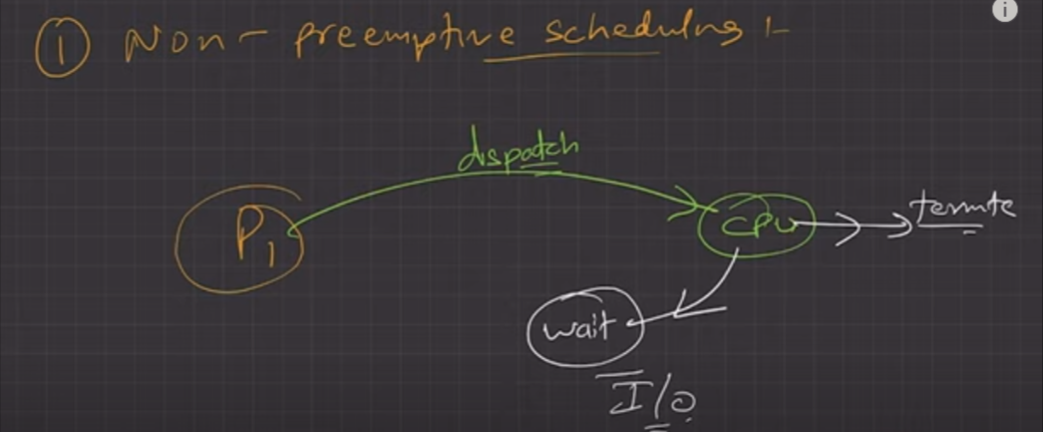

in non-preementive sheduling , once the process dispatch to the cpu , the process will going to remove from the cpu only when either the process get terminated or process move into the wating state , there should be no time sharing theire , because of that their will be process starvation .

ii) prementive sheduling

in prementive shuduling process will going to remove from the cpu when time quantum expire or process terminated or process get into a waiting state .

diffence between non-prementive and prementive :

i)process starvation will be more in non-prementive sheduling .

ii)cpu utilization will optimum in preementive sheduling .

iii)there is less change of high priority excution in non-preementive sheduling .

iv)overhead will be more in prementive (because of time sharing so it will be able to process more process )

Goal of CPU sheduling :

i)optimum cpu utlization

ii)minimnum turn around time (TAT) (time between process in ready queue to dispatch into the CPU and the process exist from the cpu )

iii) Minum wating time (no or less process strvation )

iv) minimum response time (time between process in ready queue and time it get into cpu for the first time )

v)maximum THROUGHPUT ( no of process complected per unit time )

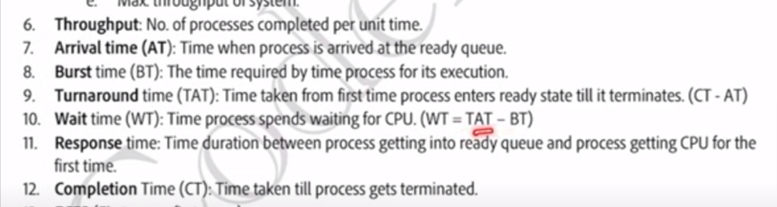

TYPE OF SHEDULING Algrotim :

i)FCFS(first come first serve)

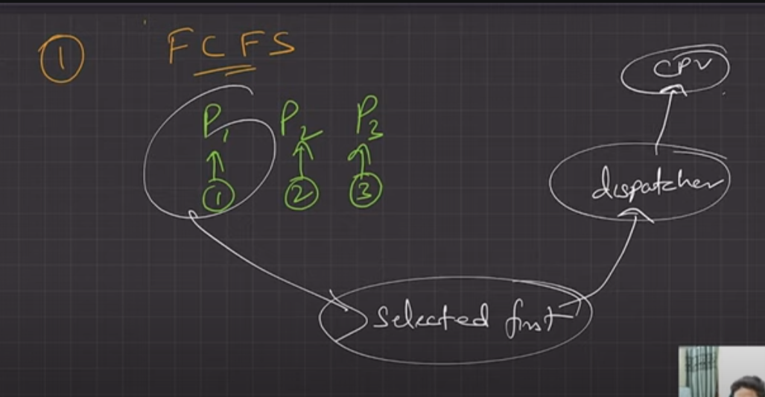

Convey Effect : it is effect when process having high burst time dispacth into the the cpu that cause to increase the avrage wating time of excution this can be understad by drawing gantt chart .

i)process with the heigest burst time dispath fist

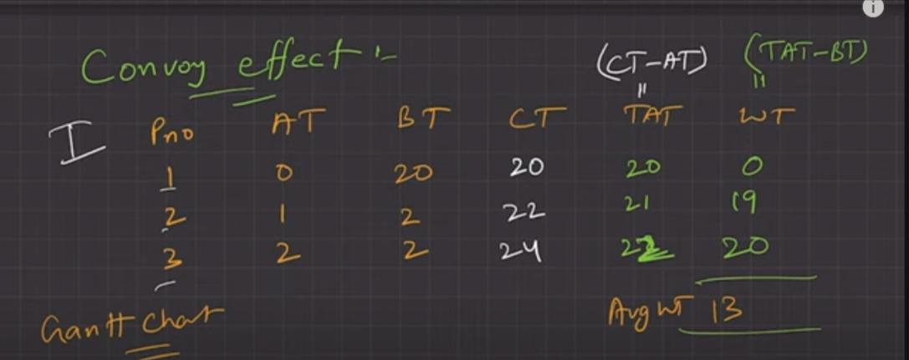

ii) process with lowest burst dispatch first

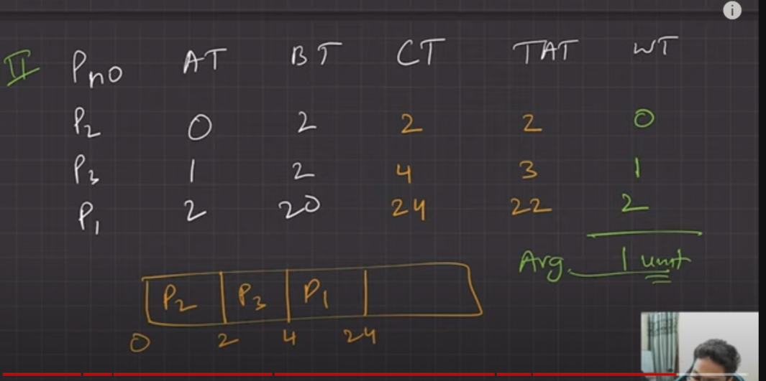

ii) SJF (short job first ) non-prementive or prementive

SJP non-preementive : process with minimum burst time will first dispatch to the cpu .

disadvantages : os estimate burst time based on size , past record based on other parameter but their is change the estimation might be wrong .

gantt chart for SJP non-prementive :

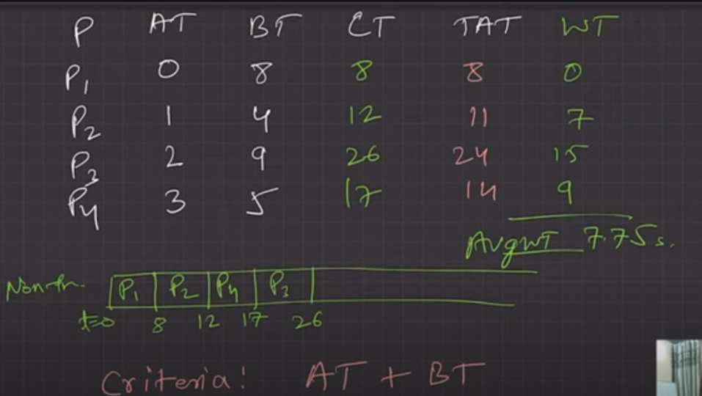

if suppose our first process have burst time 80 so there will a convey effect .

Prementive SJF:

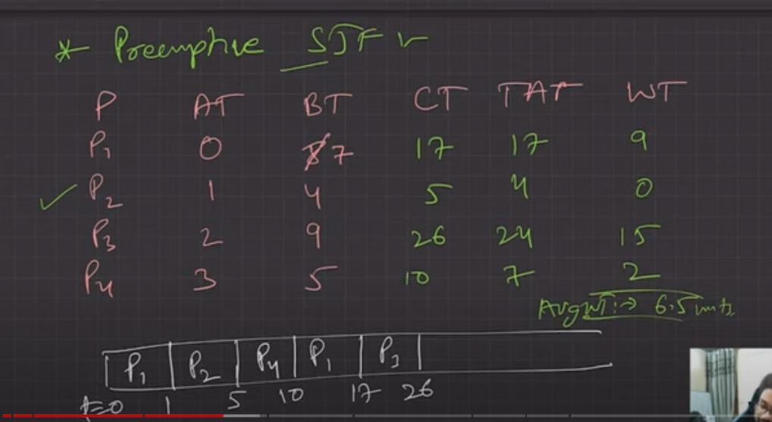

there is no convey effect

iii)priority sheduling :

in priority sheduling what it does when job comes in ready queue then a priority is set for each job .

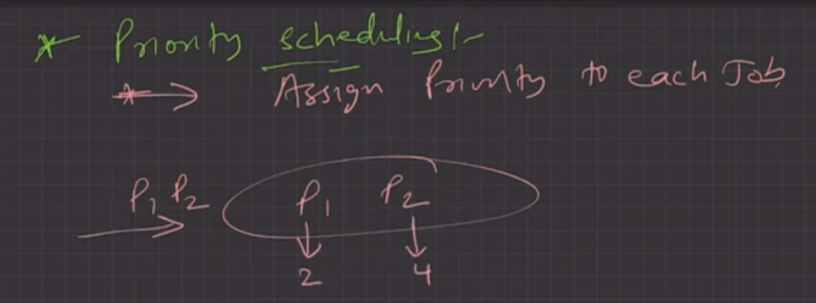

disadvantages : there in convey effect in both primentive and non prementive sheduling and also indefinite waiting or exteme stravtion

indefinite waiting or extreme stravtion :

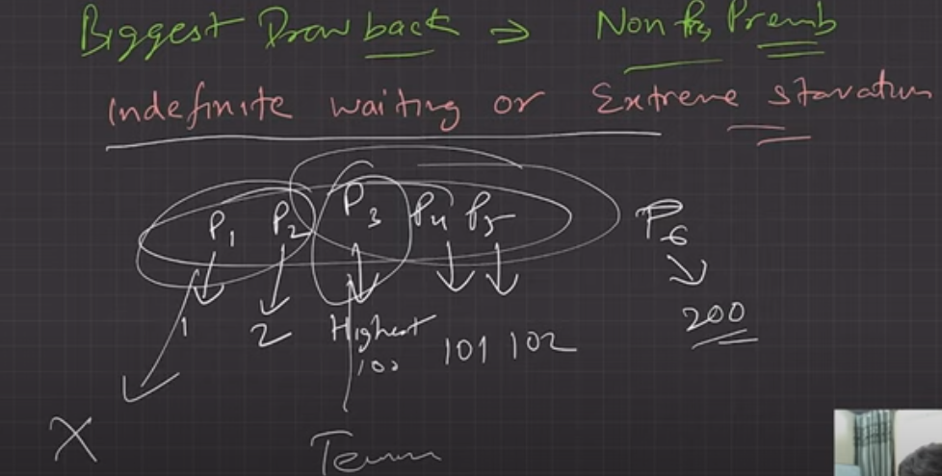

solution of indefinte waiting or extreme strvation :

ageing :

in ageing techenique what we do is we gradully increase the priority of job with lowest proirity .

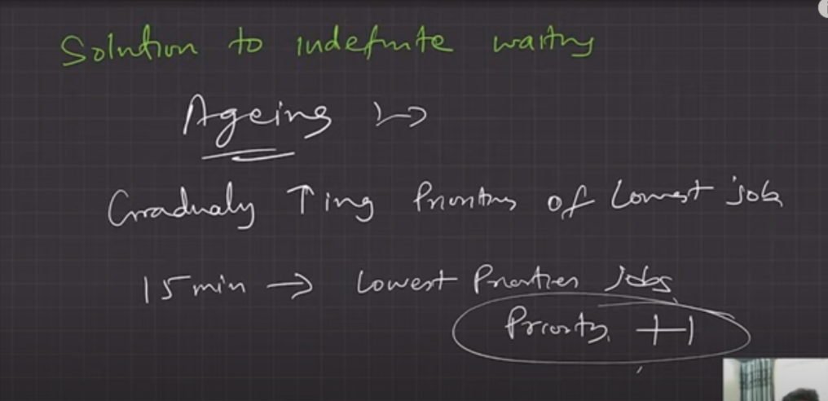

note : there is convey effect

i)Non-prementive priority shduling :

at time t=0 job with arrival time will pick first then after the burst time of first job then sheduling done on the basis sof priority , high priority will pick first

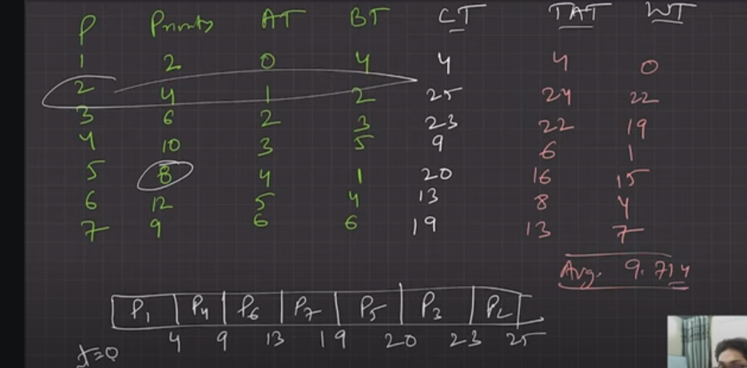

ii )prementive Priority sheduling :

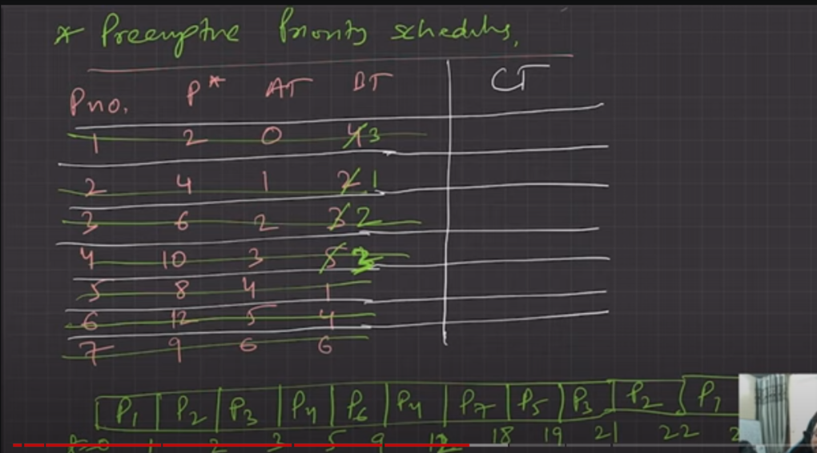

there is convey effect present and indefinite waiting or extreme strvation

iv)RR(round robin) –

i)it is prementive of FCFS shedular

ii) creteria for sheduling : AT + TQ (time quentum)

iii)most popular

iv )based of time sharing

advantages of RR: it has minimum response time , so there will be lowest strvation , there will be no convey effect no indefinite waiting or extreme strvation.

disadvatages : maximum overhead

Real world sheduling method :

i) Multi-Level Queue sheduling (MLQ)

in MLQ the process has been divided into three group

1. system process : these are the process created by OS (like init )
2. intractive process : the process required user input (eg : MS word)
3. batch process : these process run in the background

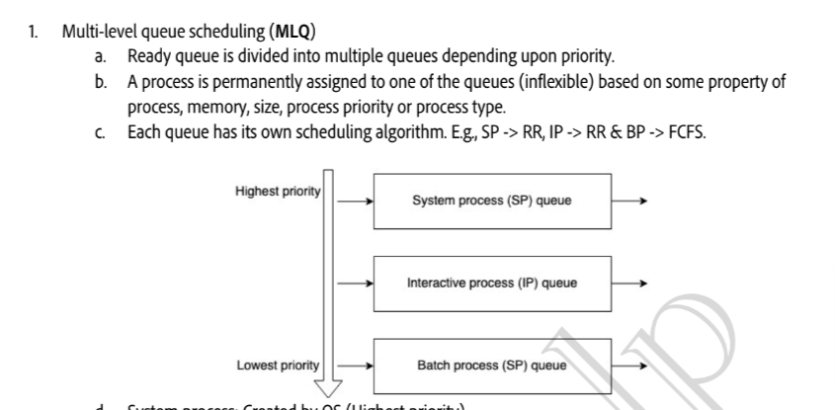

disdavantages :

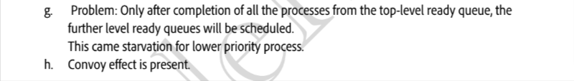

ii)MLFQ (Multi-level feedback queue sheduling)

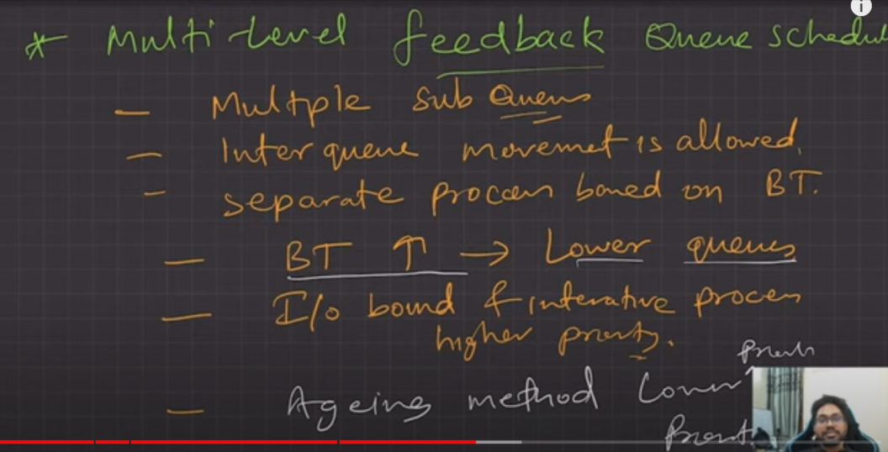

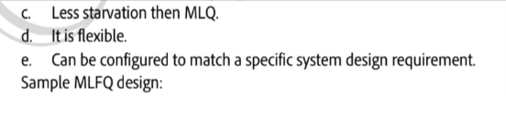

compression between all the sheduling process :

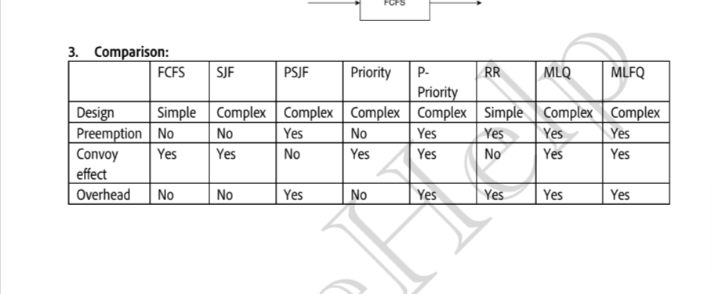

LEC-11

Concurrency

concurrency is the ability of OS in which Os can excute multiple instruction at the same time .

ii)it is done by dividing the process into multiple thread and multiple theread excuted by os at the same time .

THREAD SHEDULING :

we have TCP (thread controll block )

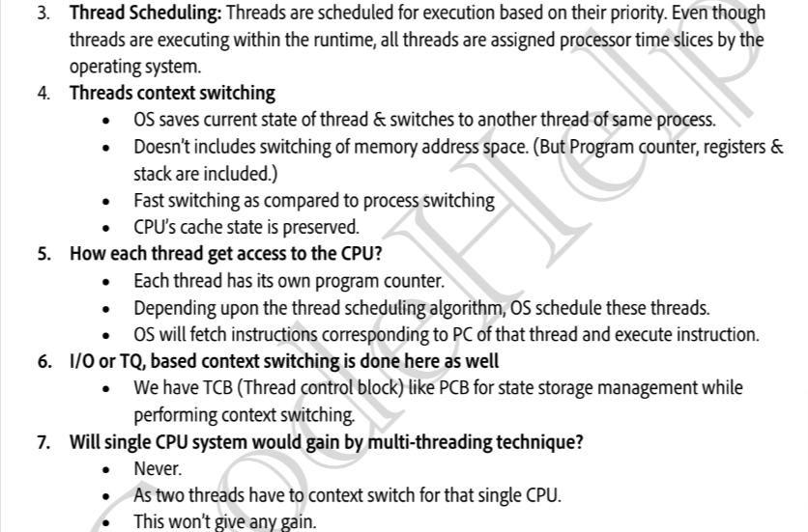

Benfit of Multi threading :

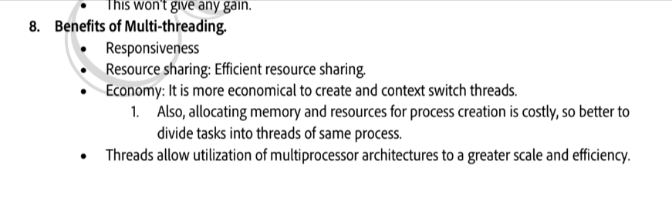

efficent resource sharing : because of shared adress ( in process , process commnicate through IPC (intel process control )

iii)contenest swithcing is fast

Race Condition : race condition is loss of data due to contest switching between thread

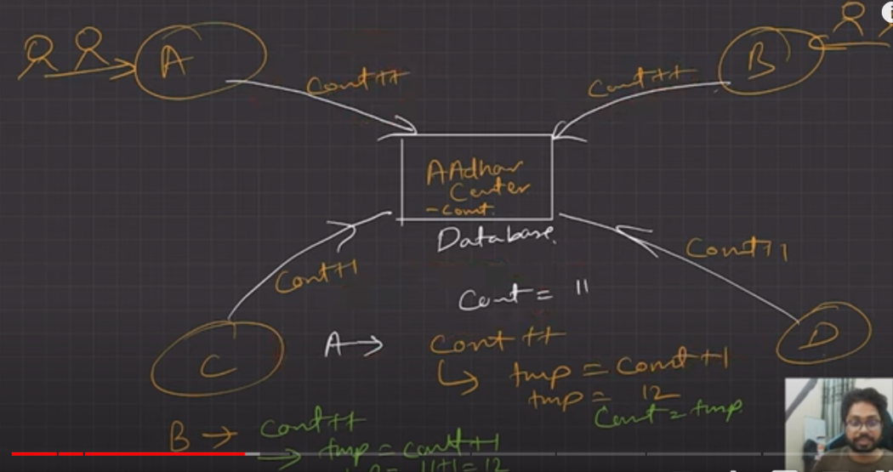

addhar center proble called as : critical section porbles

solution of race condition or critical section problem :

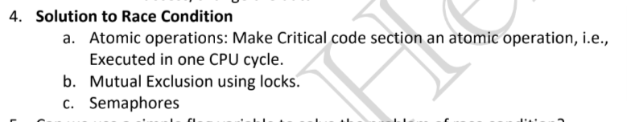

c)semaphores:

i)it is basically a integer

ii)it works with the resource with multiple instance

iii)semaphores with the value 1 called as binary semaphores and semaphores with the value greater than 1 called as counting semaphores

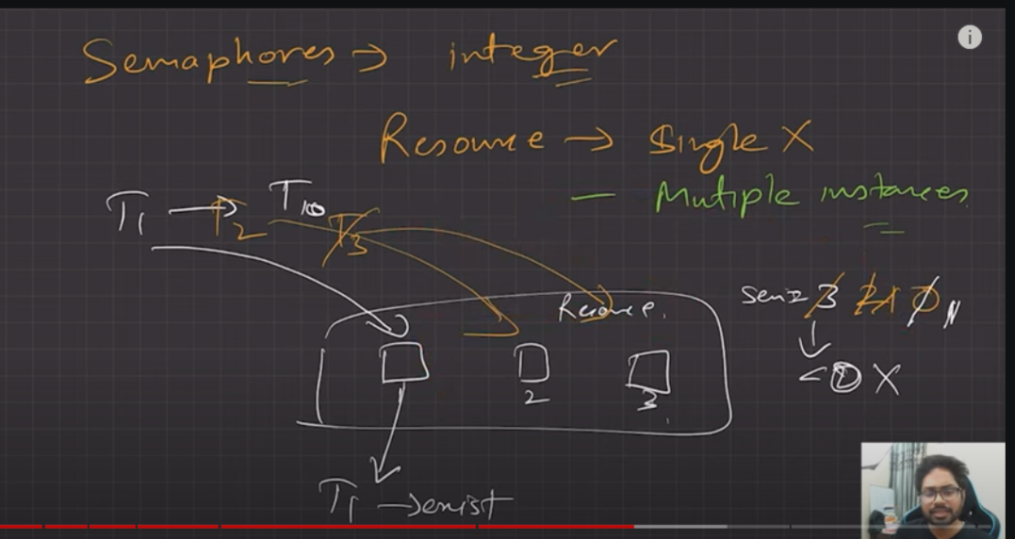

d)condition variable:

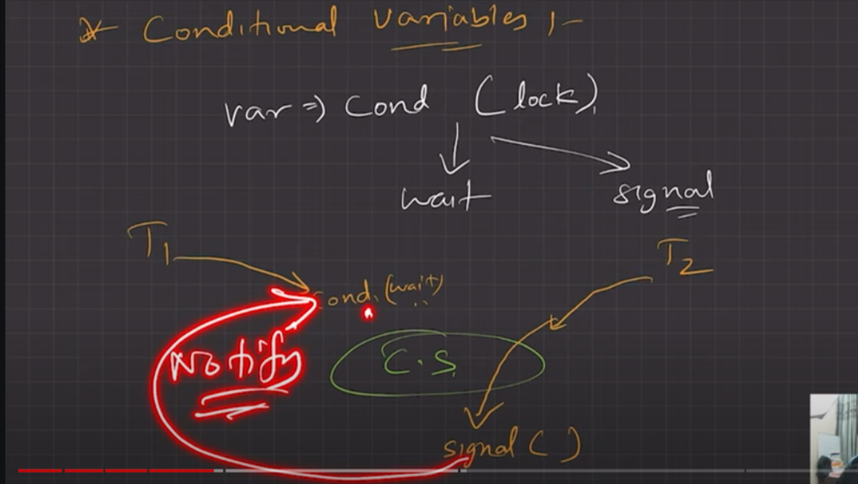

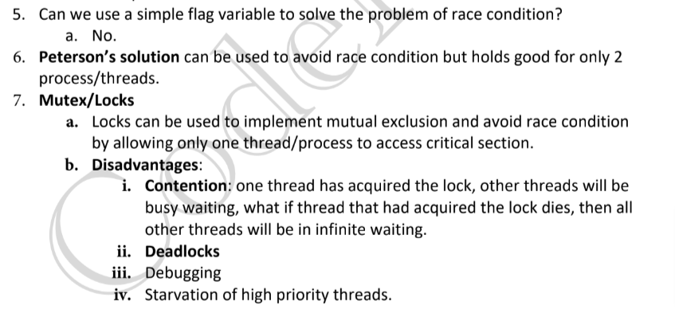

**debgging problem**

syncronisatation problem

i)producer consumer problem or bonded buffer problem

problem statement :

we have two theread:

i)producer theread will going to filled the critical section

ii)consumer therad will going to acess from the filled slot

and n slots (as critical section )

we have to create a system in which when producer therad working the consumer thread do not interfare and when consumer therad picking then producer thread do not fill the slot

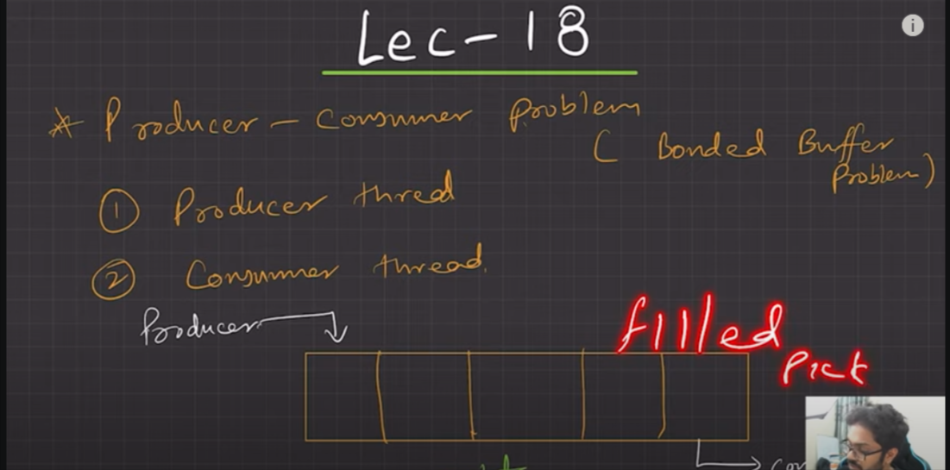

solution :by three semaphores

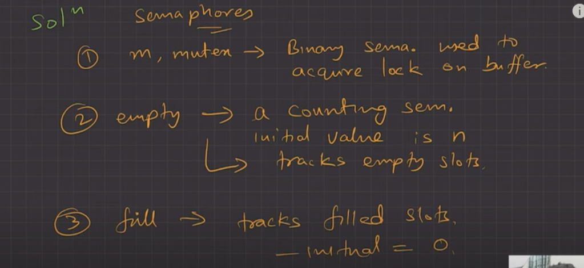

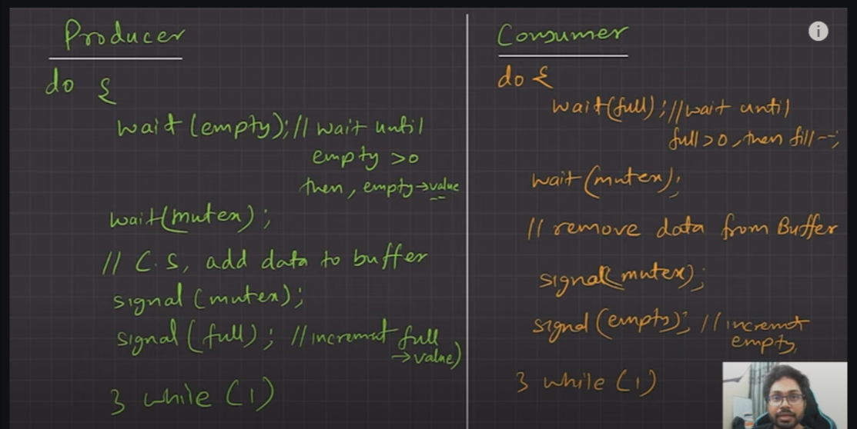

ii)Reader and writer problem

here we have two thread :

i)reader therad

ii)wirter thread

and we have database as critical section

problem : if wirte thread is wirting so we donot want reader thread to be on wating because of race condition and data inconsisent

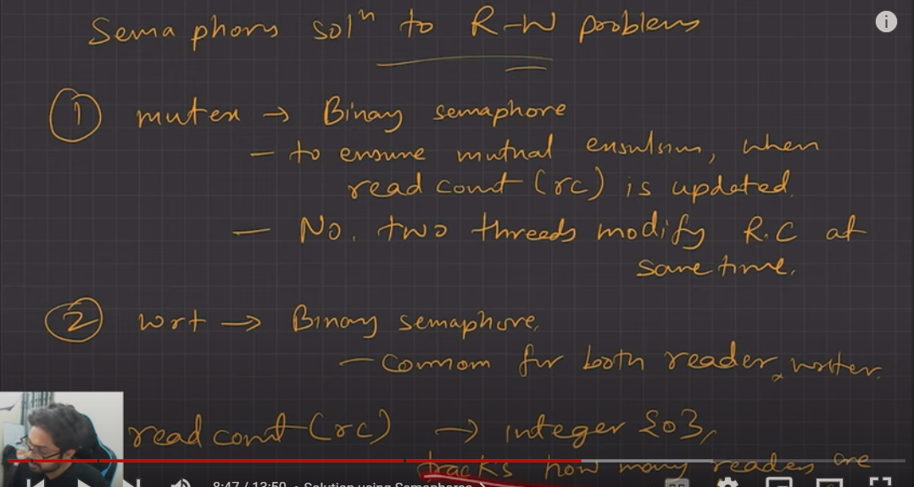

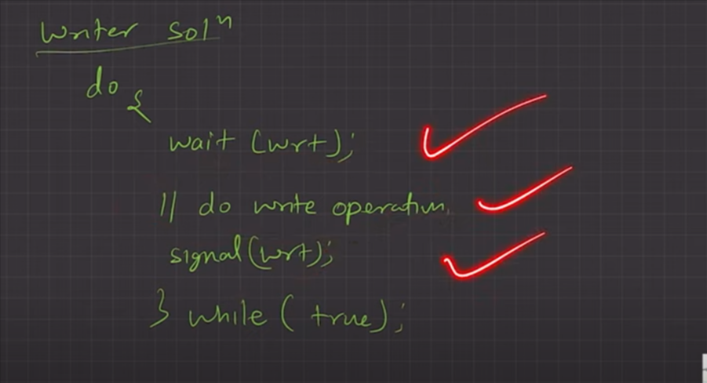

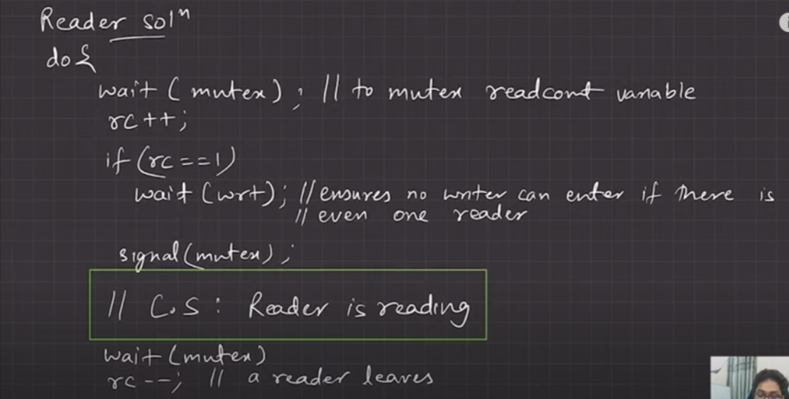

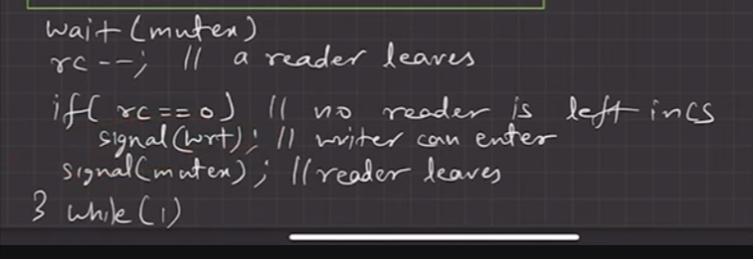

iii)The dining phliosoper problem :

we have 5 philospher , 5 fork and each philospher requires 2 fork to eat noodles , philospher either they will be in eating state or wating state

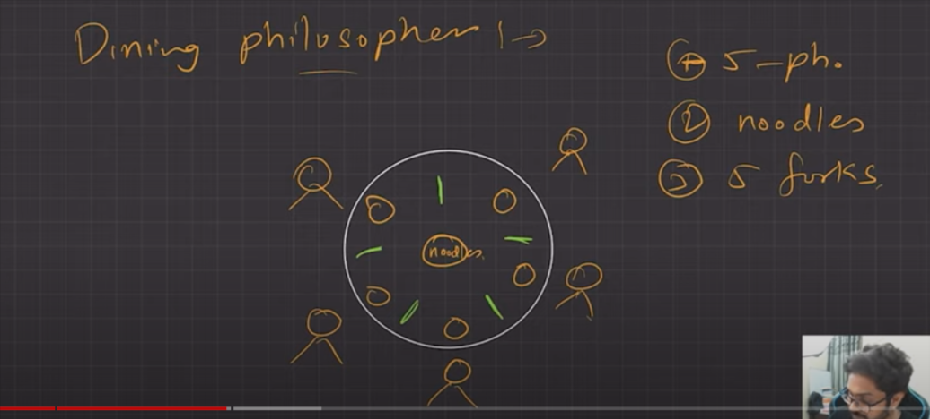

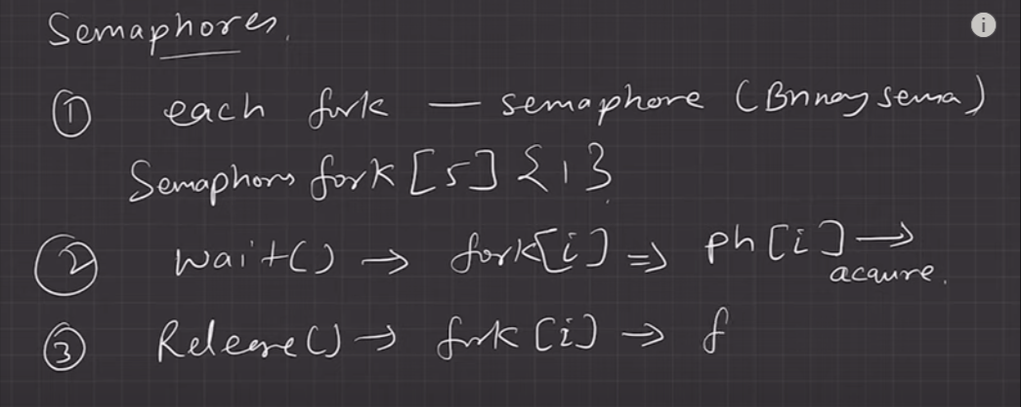

solution :

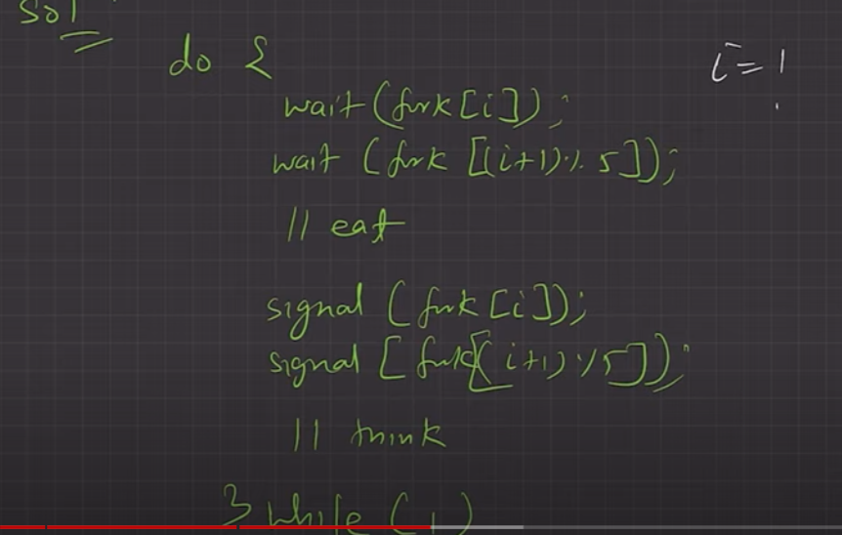

but there is problem with that solution : there is chance of deadlock , suppose each phlisopher pick right fork , there will no left fork for any of the philiphophser and create a deacklock.

solution of dead lock :

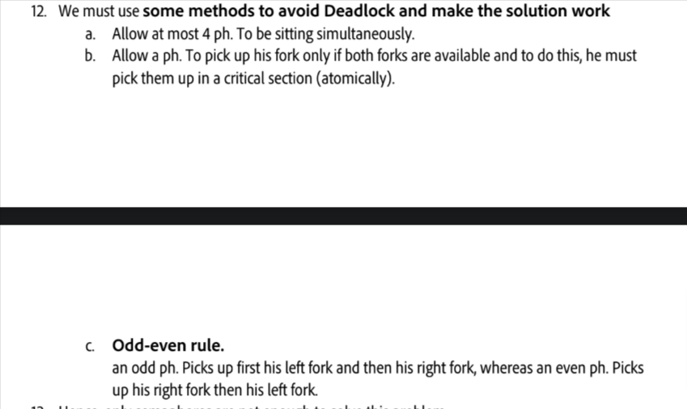

LEC-12

DeadLock :

deadlock is sistution when the excution of process gone into infinite excution due to lack of resources . eg : we have two porcess p1 and p2 and we have two instances of resources r1 and r2 for the excution of p1 and p2 process each require both instances suppose p1 get r1 and p2 get r2 it will going to create an condition of infinite excution .

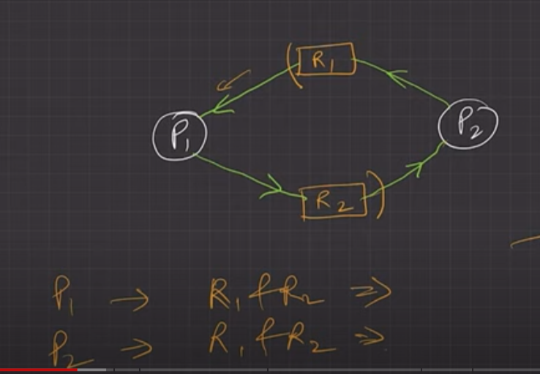

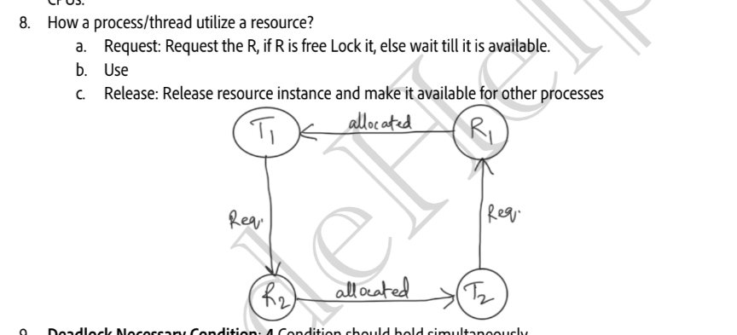

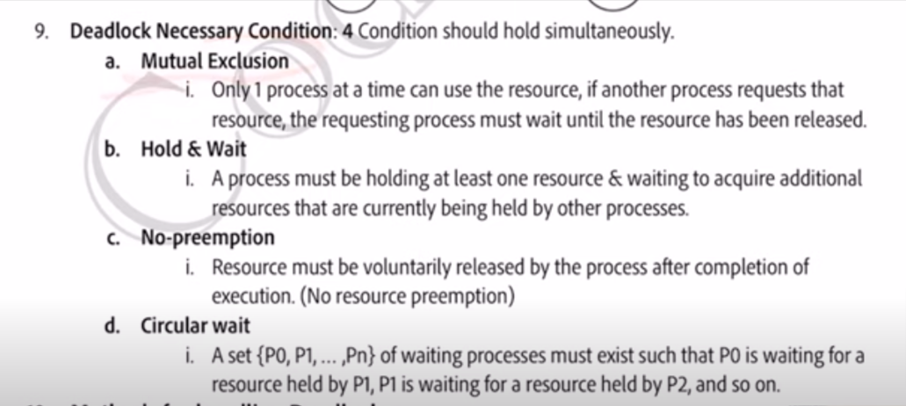

note : if any of the above condition is false then there will be no dead lock

way to identify deadlock : by drawing RAG (Resource alocation Graph)

it is grah between process and resources in the form of vertex and edges

vertex can be : resource vertex , process vertex

edge : shows which process occupy which resource

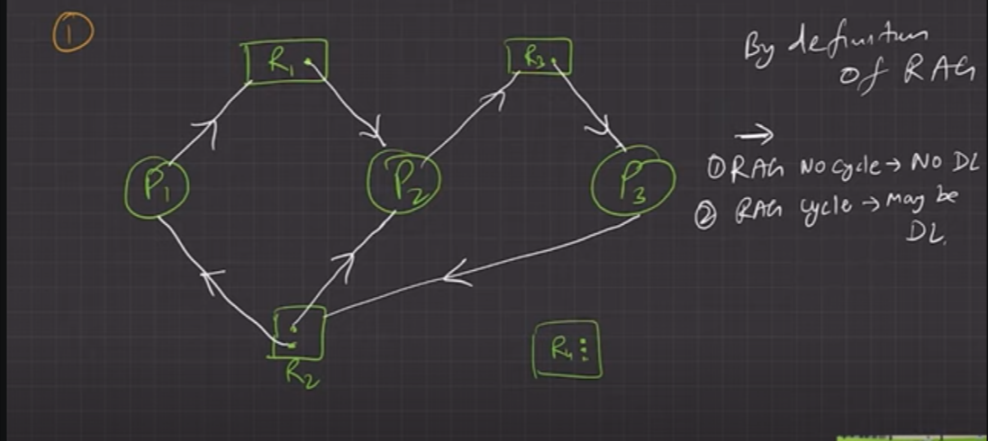

if

1. there is cycle is RAG then we can say that there may or maynot be a dead lock .
2. if there is no cycle is RAG there will be no dead lock

Method to handle deadlock

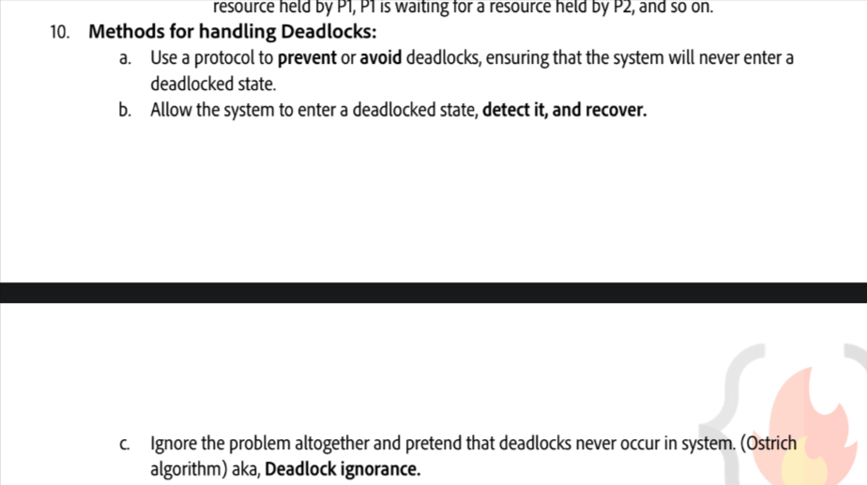

a)Deadlock prevention

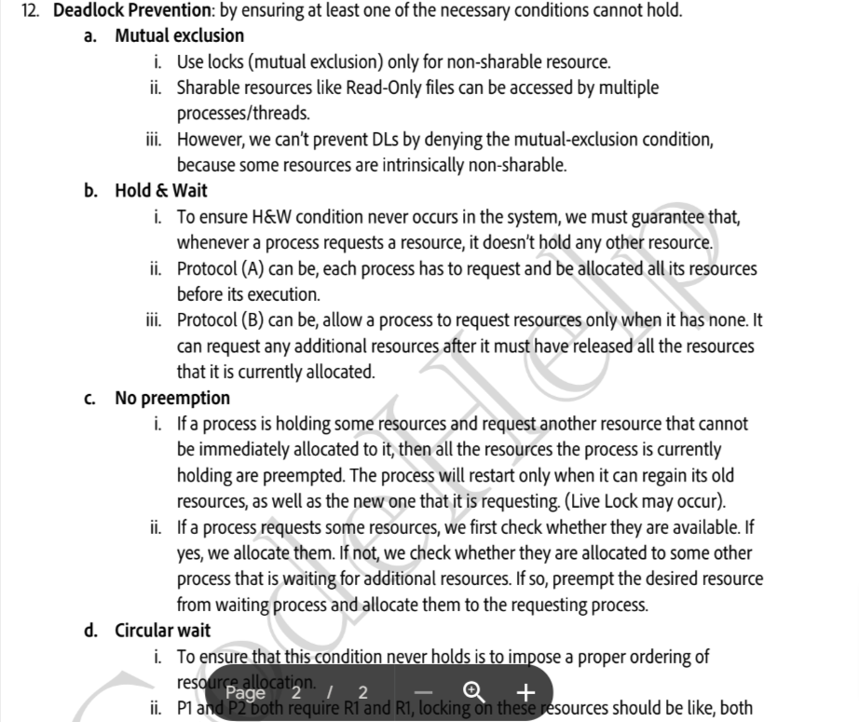

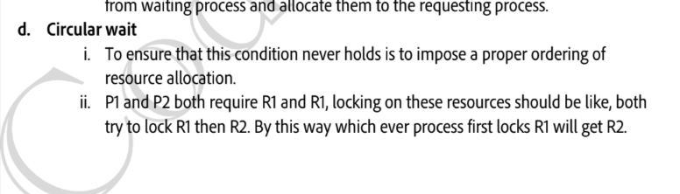

DEADLOCK AVOIDANCE :

in deadlock avoidance we use bankers algoritim to shedule the process

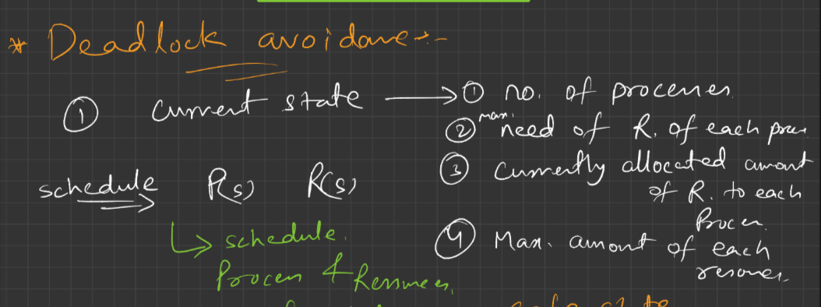

banker alorithm :

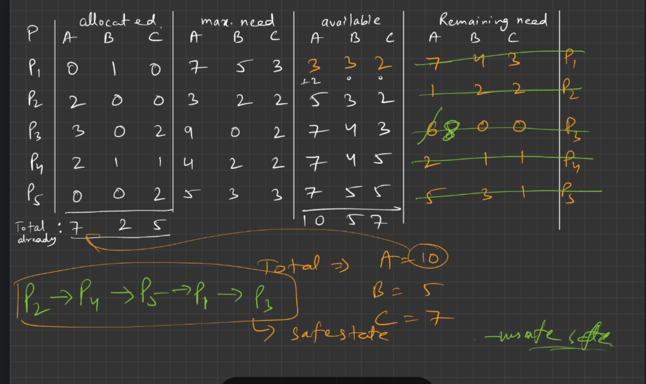

SAFE STATE AND UNSAFE STATE

safe state : through bankers algoritm the process we will be able to shedule these process are call as safe state.

unsafe state : through bankers algoritm the process we will be not able to shedule these process are call as safe state. that indicate there is deadlock present .

DEADLOCK DETECTION :

for single instance resource :

i)wait end graph method

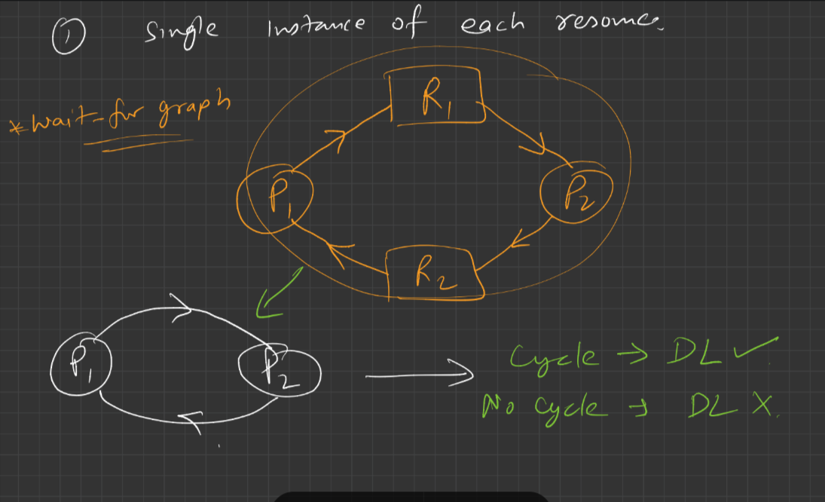

Resource with the multiple instance :

i)Bankers alorithm

if there is unsafe state present then there will be deadlock .

if there is no unsafe state present then there will be no deadlock

RECOVERY FROM THE DEADLOCK:

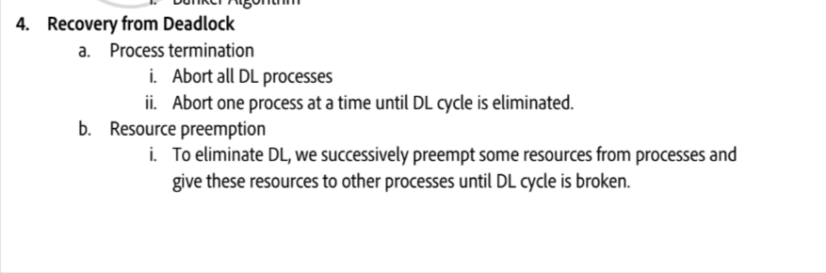

Multi threading in c++

1.creating a thread

three method :

i)function

ii)class

iii)lamda

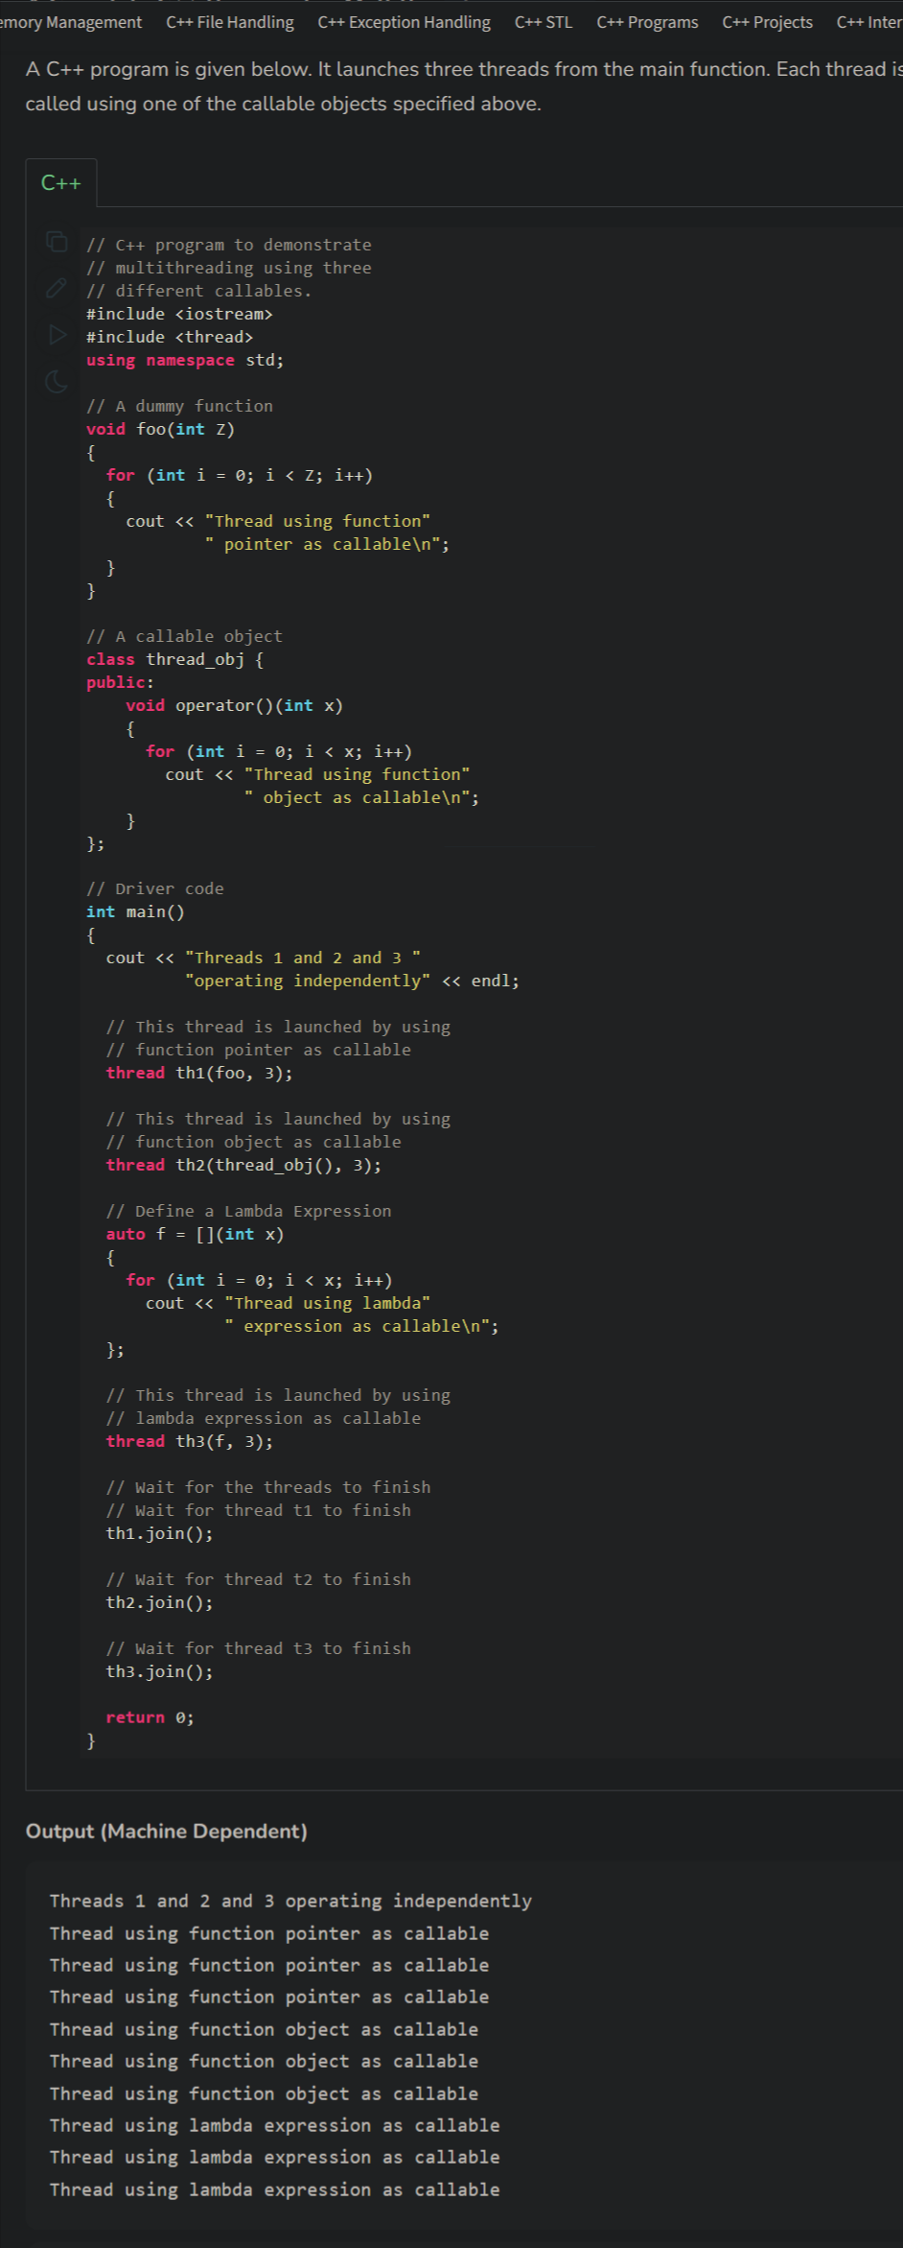

question :

1. leetcode- print in order

2. 1115. Print FooBar Alternately

3. 1116. Print Zero Even Odd

4. 1195. Fizz Buzz Multithreaded

5. 1226. The Dining Philosophers

6. 1117. Building H2O (using of pthread_barrirer)

LEC-13

MEMORY MANAGEMENT IN OS

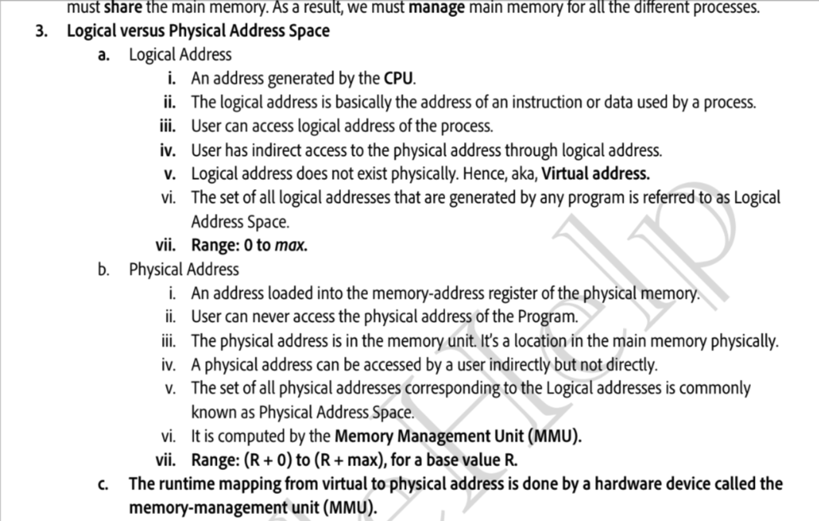

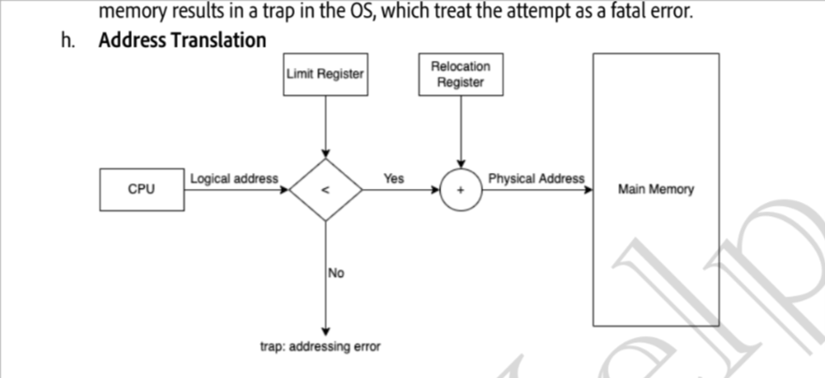

Memory allocation :

1.contigious memory allocation

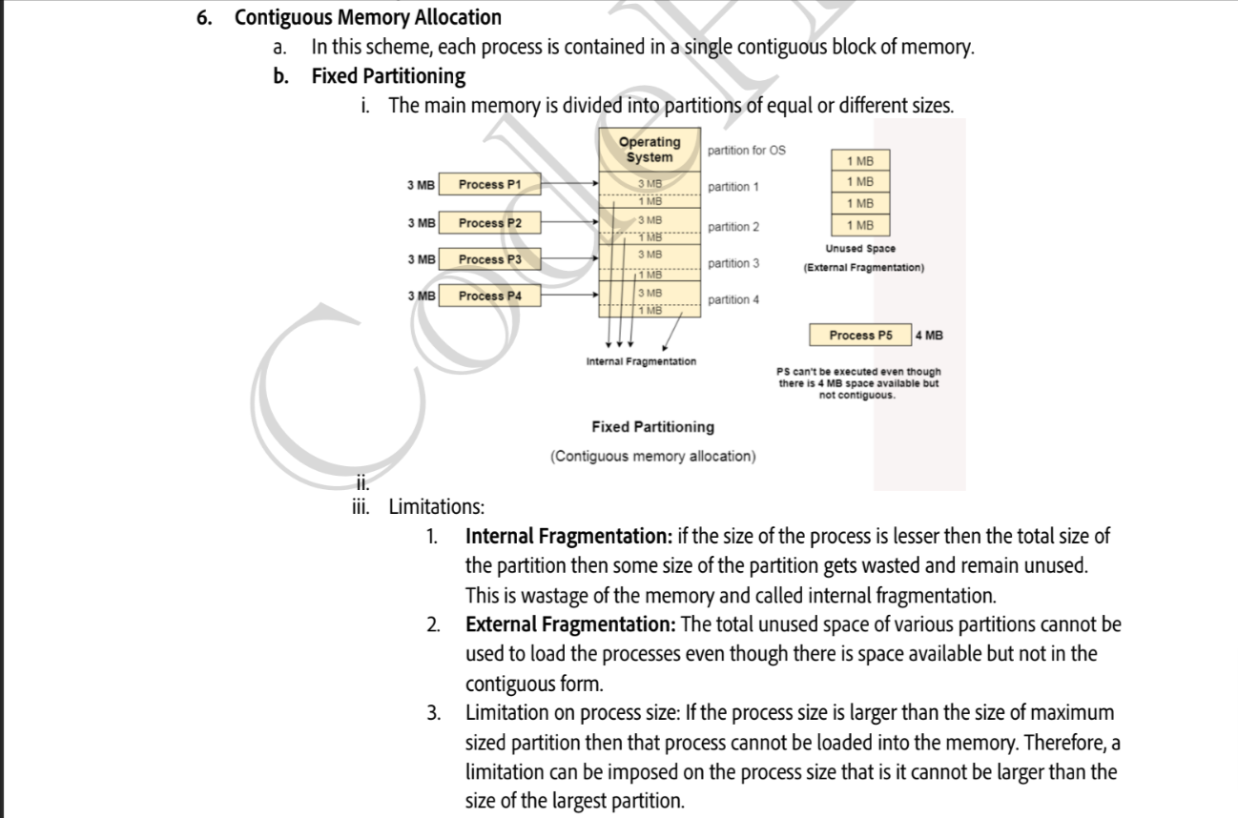

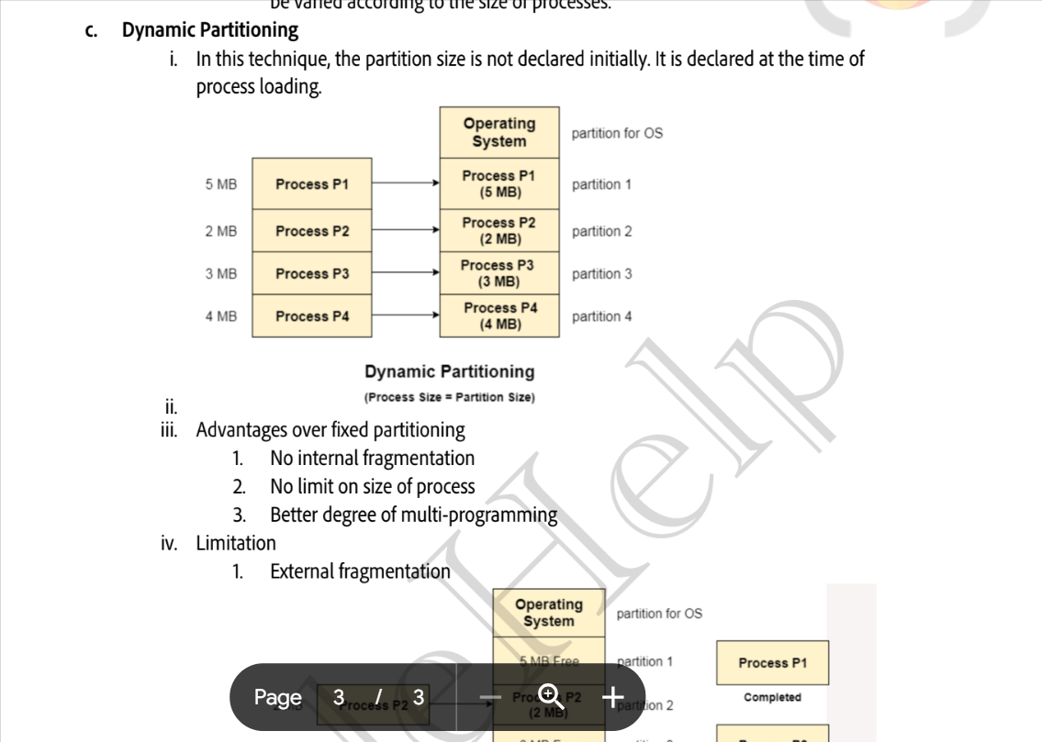

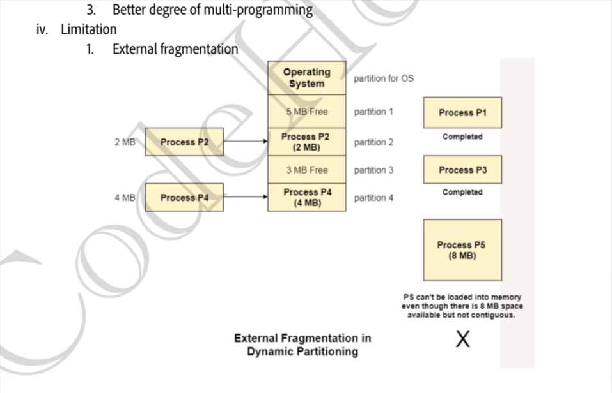

solution of external fragenmentation of dynamic partationing :

defragmentation : means seprated the deallocated space.

disadvantages of defragmentation : make process slow

How os mnages free space ?

in contigious allocation of memory the free space are sotre in list called free list (in form of linked list )

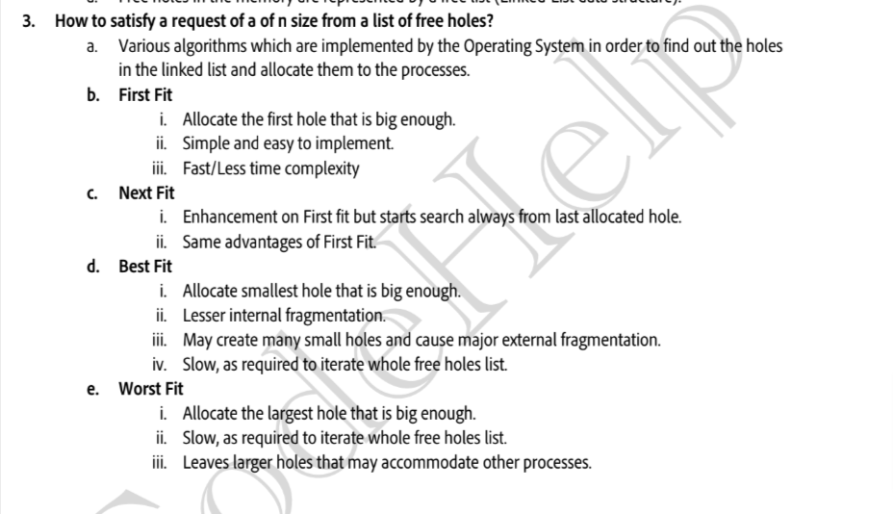

PAGING : paging is mthod of non- contigious memroy allocation .

i)in paging the process is dived into to block of fixed or dynamic size based on computer artitect and we called each block as page

ii)Ram is also divided into the fixed or dynamic size based on the computer artitect we called each block as frame

iii)to map logical address and physical adress we page table

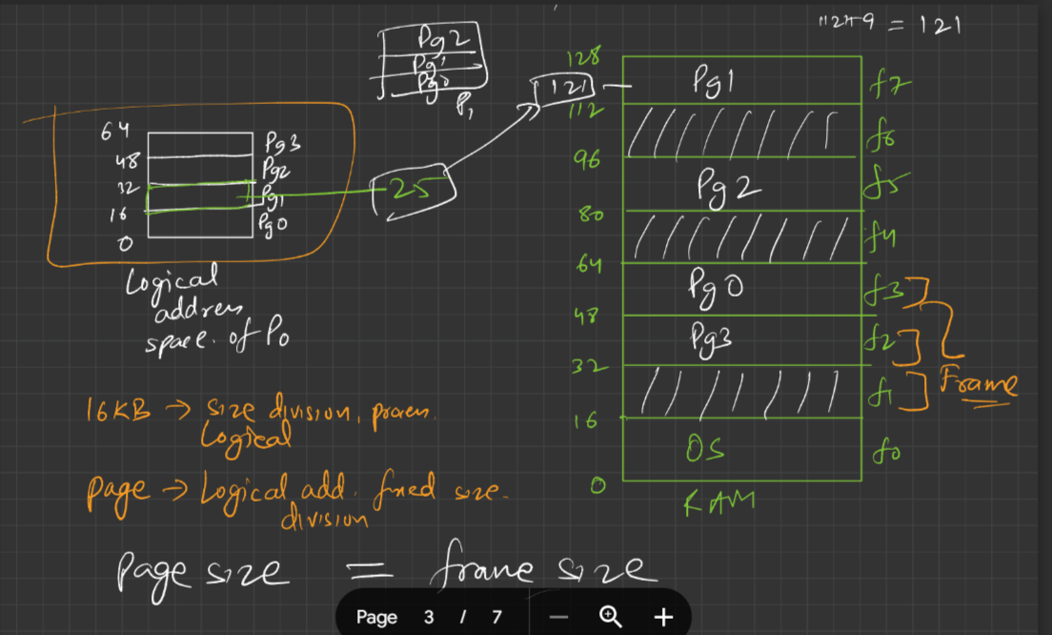

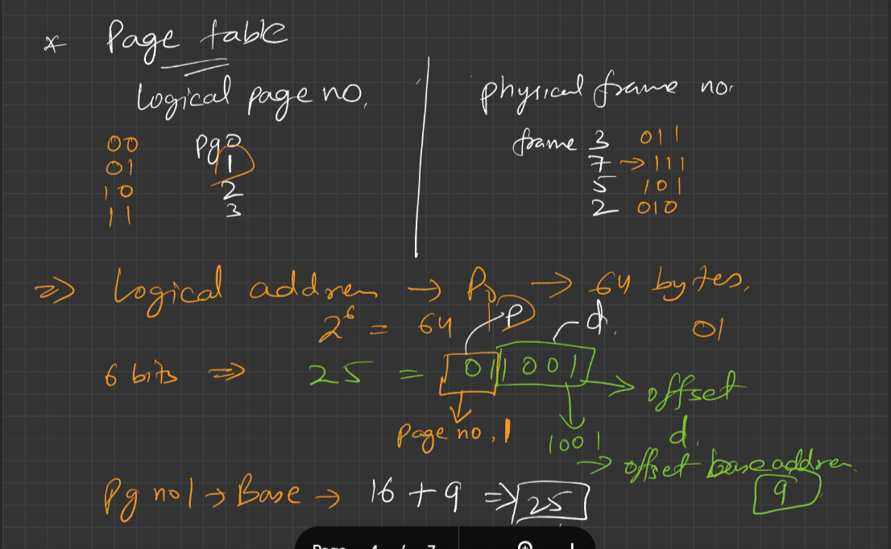

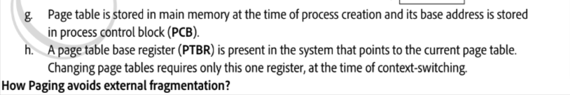

note during paging we encounter of overheading , to solve the over heading we use hardware support

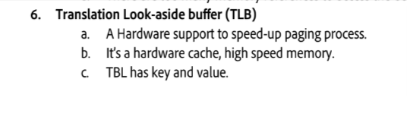

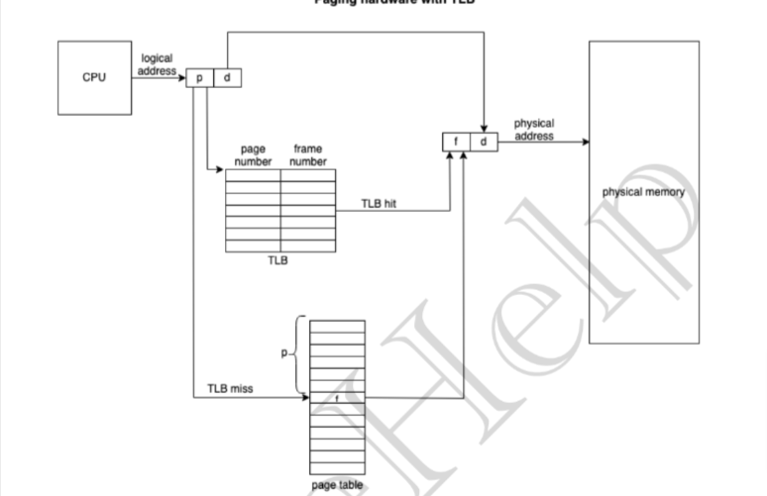

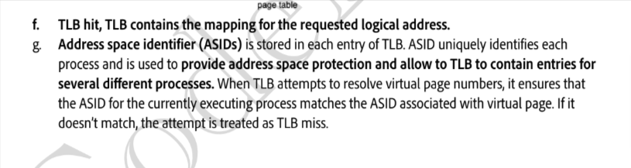

SEGMENTATION :

Segmentation is method of non-contigious memory allocation , unlike paging where we divide the process and into the fixed size of pages but in segmentation we fom a segement of variable size based on need .

segmentation also solve a problem we face in paging :

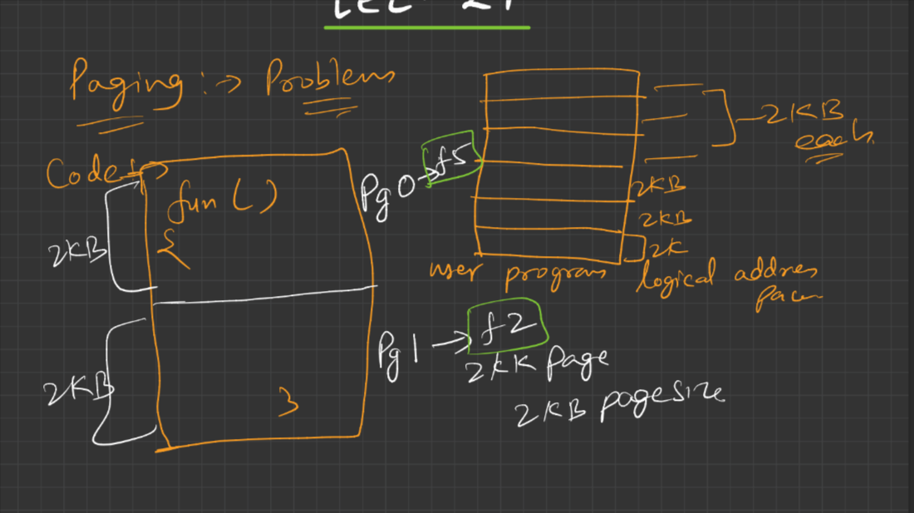

note : each segment has segment no and address



ii)each process have segment table (that have limit and base address )

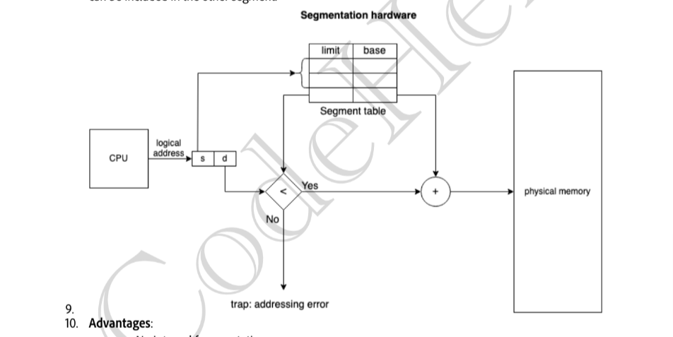

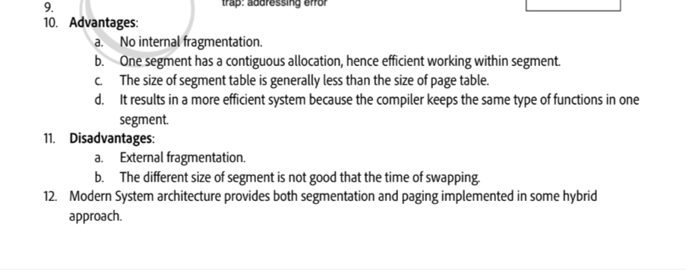

diffrence between segmentation and paging:

1. defination
2. pagging have internal fragmentation where as segmentation have external fragmentation.

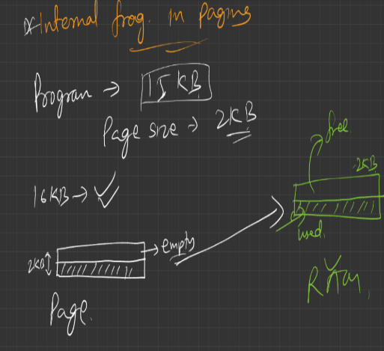 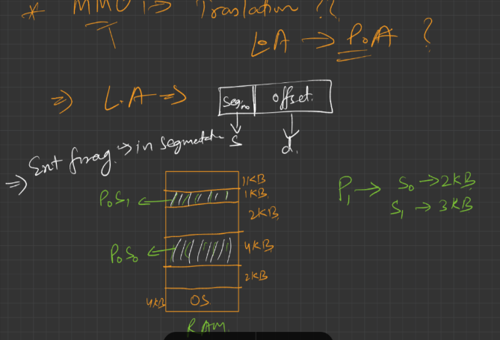

3.segementation solve a problem of same fun being called two from logical address through MMU to physical adressing .

4. artitect of paging and segmentation like (page,frame , segement , page table ,segement table )

VIRTUAL MEMORY :

virtual memory is a technique through which we will able do multiprogramming and can can application with larger size than our RAM.

What happend is :

in our ready queue we have multiple process to excute suppose pages two to three process take all the ram space so we will not be able to excute the remaning process . so with the help of virtual memory we will gooing to solve this issue , what we will going to do is we os will going to do is it will only going to load only important pages to main memory other pages will be store in ready state in a reserved space in disk we called it as swap space . when ever we need those pages will going to swap in those pages in our main memory .

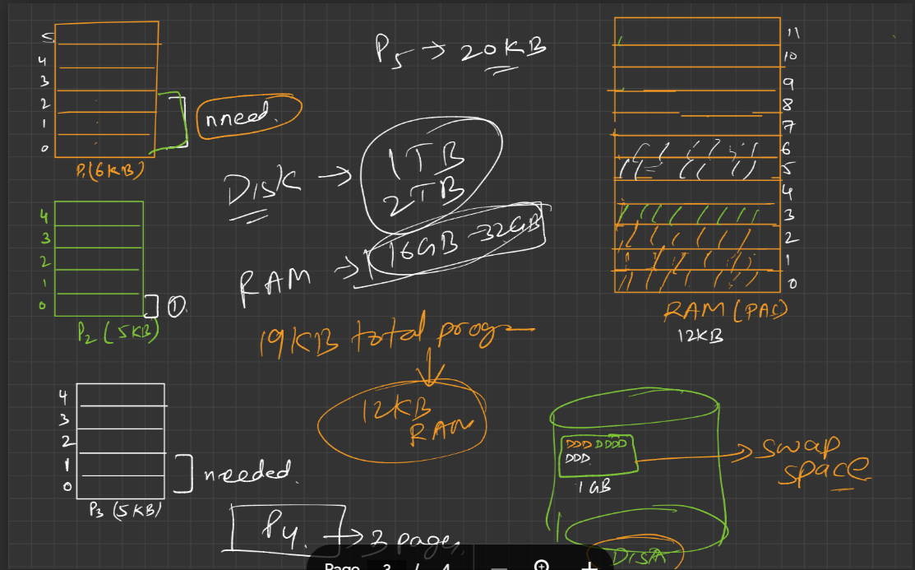

virtual memory = main memroy + swap sapce in disk

advantages and disadvantages of virtual memory :

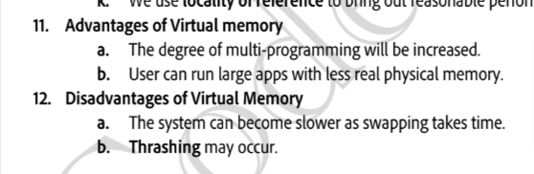

DEMAND PAGING :

Demand paging is a technique through which we will able do multiprogramming and can can application with larger size than our RAM.

important term :

i)page replacement alorigthm

ii)page falut

iii)lazy swapper

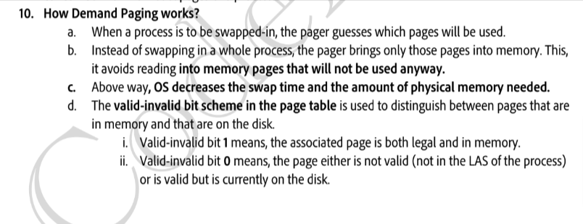

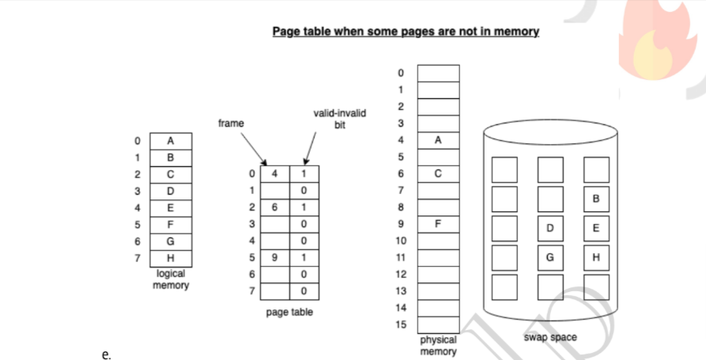

pure Deman paging :

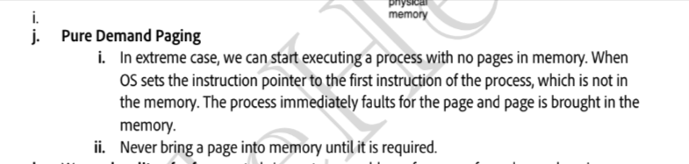

Advantages and disadvantages of demand paging :



PAGE REPLACEMENT ALGORITM :

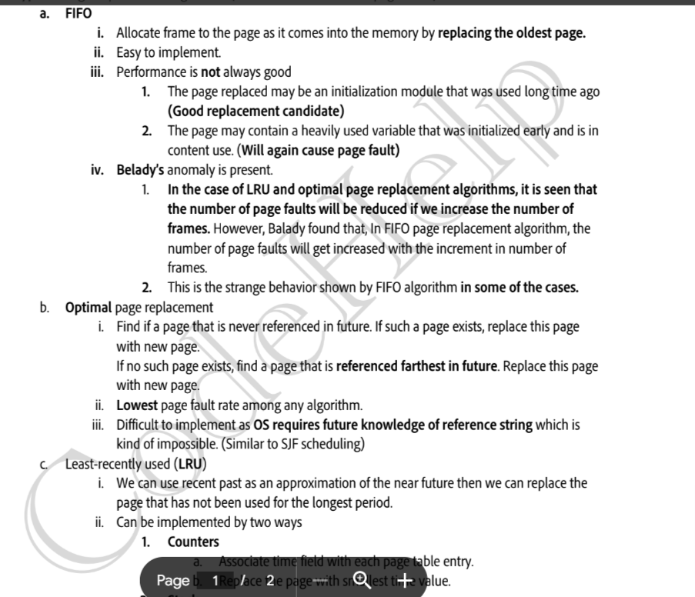

Thrashing :

